Almost as quick, will Ramadan pass!
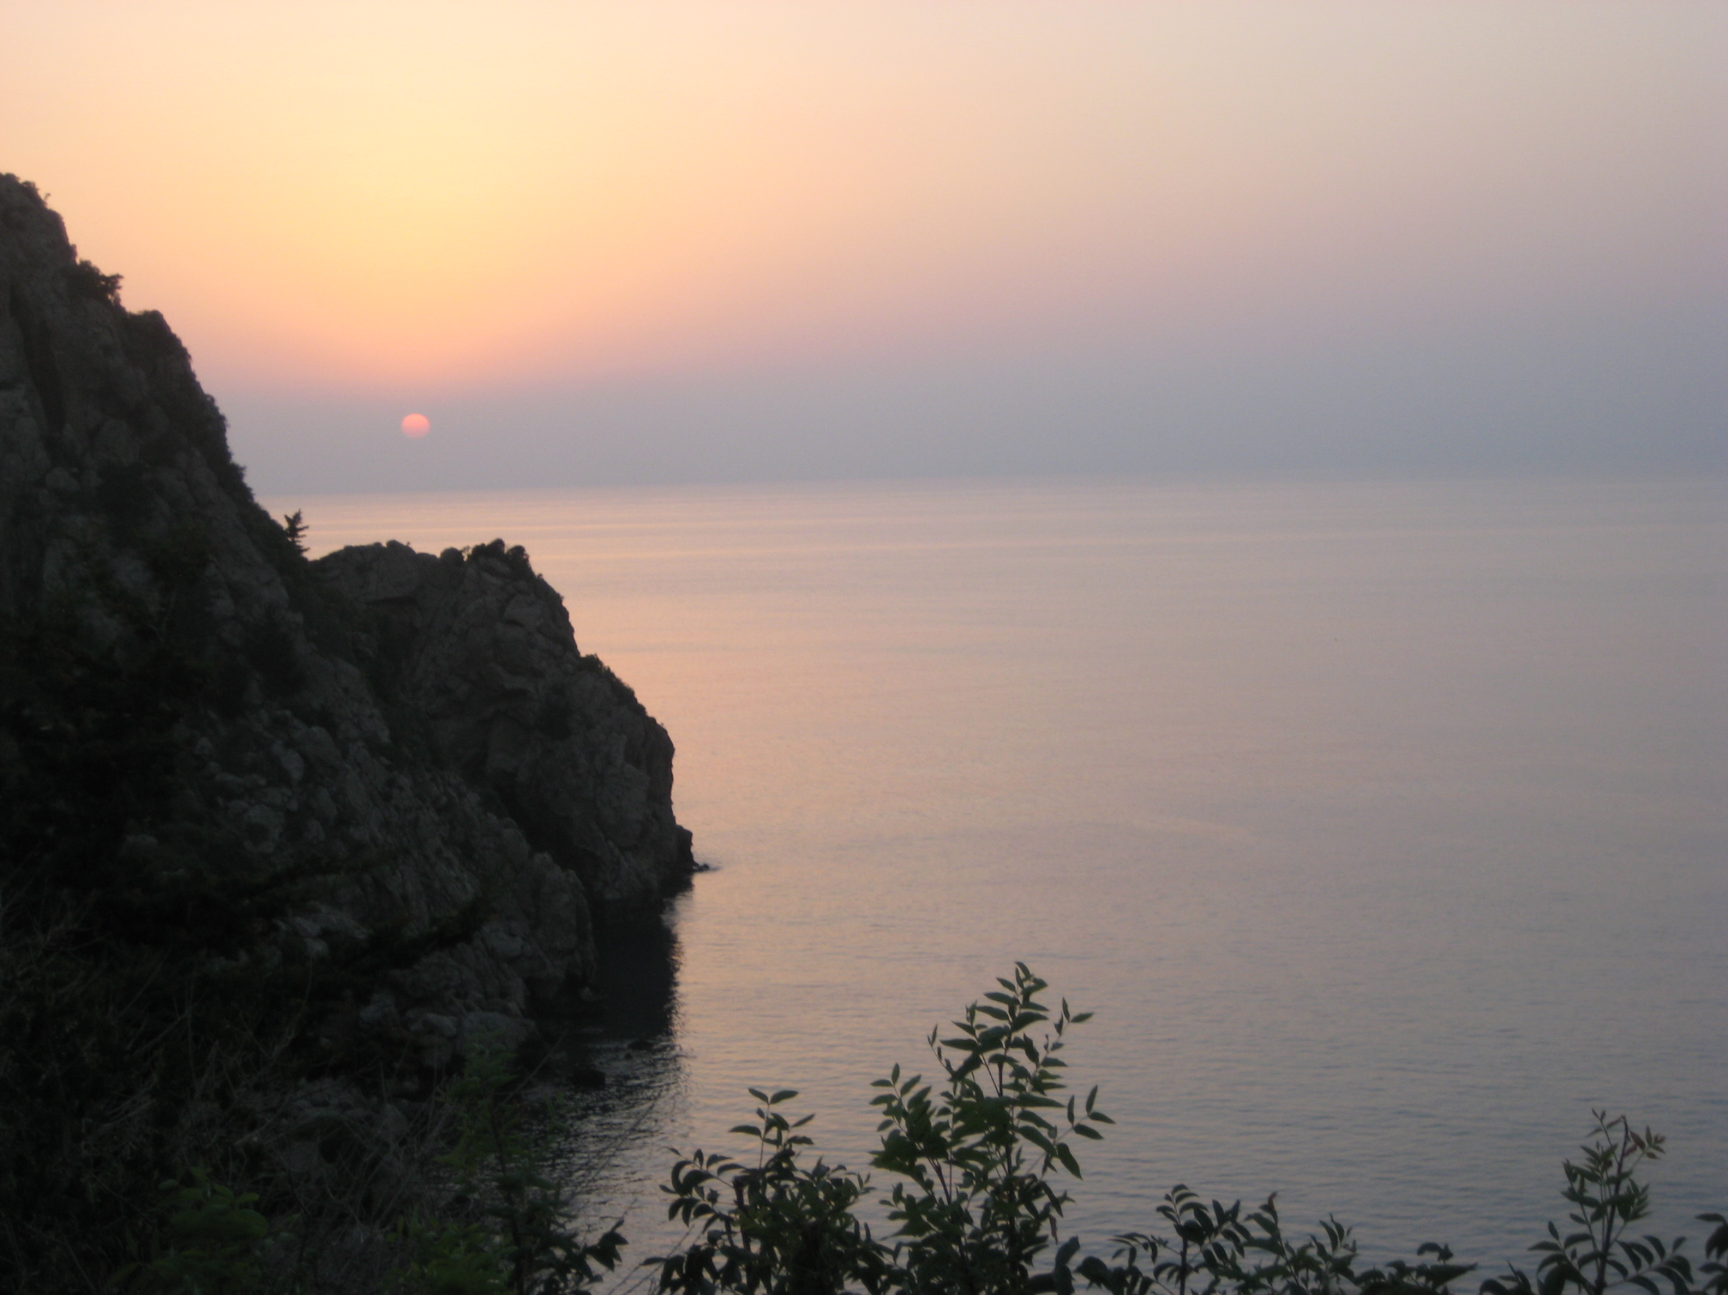
Saturday | Sunday | Monday | Tuesday | Wednesday | Thursday | Friday
 |  |  |  |  | *First night of Ramadan!  *TARAWEEH!  *Make your intention. | First day of fasting  ☺
This is the month of QURAN  Do you have a daily reading plan? | How many rikas of Taraweeh are you praying each day? | Try to give some type of sadaqa each day | Did you know that backbiting, lying and bad words can break your fast? | Plan today for the breaking of the fast of someone | Show kindness to and patience with everyone you meet | Don't forget surah al Kahf today and dua' and salat upon the Prophet
Most good habits and new beginnings occur in Ramadan | Reward for every letter of Quran:10x70x2 Do you know why? | Taraweeh is more enjoyable in jama'a  Pray with family if not at masjid | Try to give some type of sadaqa each day | Be happy!  Allah is showing you off to His angels | Watch your tongue! | Fill up your spiritual battery. It's your yearly chance!
Warning!  Don't lose your temper. Say: I'm fasting. | Gain your parents' pleasure | "If people knew what Ramadan is, they would wish the whole year were Ramadan." | How far along are you in your Quran reading?  Catch up! | Night of Power?!  Equals 83 yrs, | I help at home with a smile  ☺ | Night of Power?!  For one who takes advantage: all sins forgiven!
Thirsty?  There is a door for Jenna called Rayyan  Research it. | Night of Power?! | Tired?  Even sleep counts for one who fasts as tasbeeh! | Night of Power?! | Only hours of Ramadan left  ☹ | Night of Power?! | Seeking the moon…  Perhaps a bonus night and day!!!
The night of Eid!
Takbeer
No taraweeh

